Scenario Usefulness and Avatar Realism in an Augumented Reality-based Classroom Simulation for Preservice Teacher Training

Ilju RHA (Seoul Nat’l University)[1]

This paper introduces *SimTEACHER Mobile*, a scenario-based simulation in a mobile application that can be used by preservice teachers when their clinical teacher training is interrupted and on-site visits are limited. To present realistic scenarios, we designed augmented reality (AR)-enabled interactions for users and scenarios with two intensity levels of emotional expression by student avatars. We then examined how the AR-enabled interactions in *SimTEACHER Mobile* affect users’ perceived scenario usefulness and avatar realism. We also explored the extent to which the student avatar’s emotional intensity in a scenario influences users’ perceived scenario usefulness and avatar realism. The experiment was conducted using online meeting platform. The results of a one-way MANOVA with repeated measures showed that participants in the AR-interaction group perceived avatar realism to be significantly higher than those in the non-interactive video group. Also, participants perceived the high emotional intensity scenario (aggression toward peers) to be significantly more useful than the low emotional intensity scenario (classroom disruption). AR interactions improved the user’s perception of the realism of student avatars while the high-intensity scenario increased the usefulness of the scenario.

Keywords: Teaching simulation, Augmented reality, Mobile application, Classroom management

**Introduction**

The pioneers of the field like Durkheim and McLuhan had already foreseen the emergence of social network resulting from the combination of various technologies such as human creativity and the development of electricity. Durkheim insists that ‘social phenomenon’ is the reality constructed by the interaction among individuals, and that it progresses through organic solidarity which accepts individual specialization (Freeman, 2004). In his work ‘Understanding Media’, Marshall McLuhan (1964) anticipated that media would not stay limited to personal uses, but would continue to cultivate social relationships. He perceived electricity as playing a major role in expanding and integrating humanity for electricity makes all the other electric media possible. The nature of electricity is to connect things, even beyond the spatial dimension. It connects a machine to a machine and a person to others. So it seems that social network has emerged as a product of people's basic social needs and computer communication technology.

The Reality of Social Network

The history of social network

The history of social network is not too long. The first social networking sites or services (SNS) launched in 1997, and since then only 14 years have passed. Nevertheless, the change it has brought about is enormous. SNS bean with SixDegrees.com in 1997, where a user could upload his profile, search for friends, and share profiles with friends (boyd & Ellison, 2008). But SixDegrees.com discontinued its service in 2000. Although the number of users was increasing, they had difficulty expanding its system large enough to sustain all the users at that time (boyd & Ellison, 2008).

|  |  |  |
| --- | --- | --- |
| Table 1  D-aspects and S-aspects of SNS affecting to the four components of education curriculum | | |
| Four components  of educational  curriculum | D-aspects | S-aspects |
| Educational  objective | ▫ Change to selecting educational objectives  ▫ More considerations required while selecting educational objectives | Immediate  reflection  of learner's  needs |
| Content | ▫ Dramatic change to the construction of content  ▫ Subjects that need to be taken down | Diversity of  content |
| Process of  learning experience | ▫ Dramatic change to teaching- learning situation | Diversity of learning  Experiences |
| Evaluation | ▫ Change to evaluation of academic achievement  ▫ Evaluation of problem solving and higher order thinking skills | Diversity of  evaluation methods |

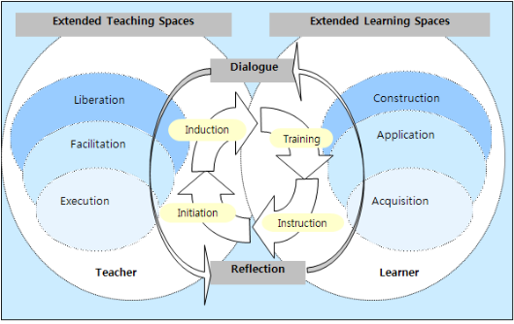Figure 1. Extended learning spaces in e-learning (Jung & Latchem, 2009)

References

Bhola, H. S. (1988). The CLER model of innovation diffusion, planned change, and development: A conceptual update and applications. *Knowledge, Technology* & *Policy, 1*(4), 56-66.

Bhola, H. S. (1982). Planning change in education and development: The CLER model in the context of a mega model. *Viewpoints in Teaching and Learning, 58*(4), 1-35.

Freeman, L. C. (2004). *The Development of Social Network Analysis: A study in the sociology of science*. Empirical Press.

Gredler, M. E. (1997). *Learning and Instruction: Theory Into Practice* (3rd ed). Prentice-Hall.

Greenhow, C., & Robelia, B. (2009). Old communication, new literacies: Social network sites as social learning resources. *Journal of Computer Mediated Communication, 14*(4), 1130–1161.

Received: April 7, 2012 / Peer review completed: April 23, 2012 / Accepted: April 29, 2012

1. Professor, Dept. of Education, College of Education, Seoul National University (iljurha@snu.ac.kr)